# MOROGORO BIBLE COLLEGE

# The parables in Matthew

## What is a parable?

### Greek parabolē means putting two things side by side: a comparison

### Hebrew mašal covers a variety of things in OT

#### proverbial saying, e.g. 1 Samuel 10:12; Ezekiel 12:22-23

#### byword, e.g. Psalms 44:14; 69:11

#### pictorial prophetic speech, e.g. Numbers 23:7, 18, etc.

#### allegory, e.g. Ezekiel 17 (NB v 2)

#### similitude, parable, e.g. Ezekiel 24:3-14

#### poem, e.g. Numbers 21:27-30 (NB v 27 ‘they that speak in poems’)

#### sentences of ethical wisdom (proverbs), e.g. Proverbs 10:1; 1 Samuel 24:13; cf. Luke 4:23

#### riddles, e.g. Judges 14:12

#### definition by C. H. Dodd: ‘At its simplest a parable is a metaphor or simile drawn from nature or common life, arresting the hearer by its vividness or strangeness, and leaving the mind in sufficient doubt about its precise application to tease it into active thought.’ (C. H. Dodd, *Parables of the Kingdom*, 5)

## The parables of Jesus [based on ‘Parable’ in the *Dictionary of Jesus and the Gospels*]

|  | *Mark* | *Matthew* | *Luke* |
| --- | --- | --- | --- |
| **Markan Parables** |  |  |  |
| Bridegroom’s Guests | 2:19–20 | 9:15 | 5:33–39 |
| Unshrunk Cloth | 2:21 | 9:16 | 5:36 |
| New Wine | 2:22 | 9:17 | 5:37–39 |
| Strong Man Bound | 3:22–27 | 12:29–30 | 11:21–23 |
| Sower | 4:1–9, 13–20 | 13:1–9, 18–23 | 8:4–8, 11–15 |
| Lamp and Measure | 4:21–25 |  | 8:16–18 |
| Seed Growing Secretly | 4:26–29 |  |  |
| Mustard Seed | 4:30–32 | 13:31–32 | 13:18–19 |
| Wicked Tenants | 12:1–12 | 21:33–46 | 20:9–19 |
| Budding Fig Tree | 13:28–32 | 24:32–36 | 21:29–33 |
| Watchman | 13:34–36 |  | 12:35–38 |
| **Parables shared by Matthew and Luke (Q)** | | | |
| Wise and Foolish Builders |  | 7:24–27 | 6:47–49 |
| Father and Children’ Requests | 7:9–11 | 11:11–13 |  |
| Two Ways/Doors |  | 7:13–14 | 13:23–27 |
| Leaven |  | 13:31–32 | 13:20–21 |
| Lost Sheep |  | 18:12–14 | 15:1–7 |
| Wedding Banquet |  | 22:1–14 | 14:15–24 |
| Thief in the Night |  | 24:42–44 | 12:39–40 |
| Faithful and Unfaithful Steward | 24:45–51 | 12:42–46 |  |
| Talents and Pounds |  | 25:14–30 | 19:11–27 |
| **Parables found only in Matthew** |  |  |  |
| Good and Bad Trees |  | 7:16–20 |  |
| Fishnet |  | 13:47–50 |  |
| Wheat and tares |  | 13:24–30, 36–43 |  |
| Treasure |  | 13:44 |  |
| Pearl |  | 13:45–46 |  |
| Unmerciful Servant |  | 18:23–35 |  |
| Laborers in the Vineyard |  | 20:1–16 |  |
| Two Sons |  | 21:28–32 |  |
| Wise and Foolish Maidens |  | 25:1–13 |  |
| Sheep and Goats |  | 25:31–46 |  |
| **Parables found only in Luke** |  |  |  |
| Two Debtors |  |  | 7:41–50 |
| Good Samaritan |  |  | 10:25–37 |
| Friend at Midnight |  |  | 11:5–8 |
| Rich Fool |  |  | 12:13–21 |
| Barren Fig Tree |  |  | 13:6–9 |
| Tower Builder |  |  | 14:28–30 |
| Warring King |  |  | 14:31–33 |
| Lost Sheep |  |  | 15:1–7 |
| Lost Coin |  |  | 15:8–10 |
| Prodigal Son |  |  | 15:11–32 |
| Unjust Steward |  |  | 16:1–8 |
| Rich Man and Lazarus |  |  | 16:19–31 |
| Humble Servant |  |  | 17:7–10 |
| Unjust Judge |  |  | 18:1–8 |
| Pharisee and Tax Collector |  |  | 18:9–14 |
| **Parables found only in John** |  |  |  |
| Good Shepherd (10:1–18; cf. Matthew 18:12-14; Luke 15:1-7) |  |  |  |
| True Vine (15:1–8) |  |  |  |

## Parables are a key feature of Gospel sources

### 16% of Mark; 20% of Q; 43% of M; 52% of L

### Matthew’s parables

#### Matthew has the largest grouping of parables in any one chapter of the Gospels at the exact literary center or pivot of his narrative, ch. 13

##### Ch. 13 is the time when Jesus increasingly focuses on his disciples and on people outside Israel because of his homeland's growing rejection of him.

##### Ch. 13 is thus a key transition from Jesus revealing himself to Israel, and, as often in Matthew, the Old Testament is quoted (Matthew 13:35; cf. Psalm 78:2)

## Some approaches to interpreting the parables of Jesus

### allegorical: e.g. Augustine on the Good Samaritan Luke 10:29-37

#### *A certain man* went down from Jerusalem to Jericho: Adam himself is meant; *Jerusalem* is the heavenly city of peace, from whose blessedness Adam fell; *Jericho* means the moon, and signifies our mortality, because it is born, waxes, wanes and dies. *Thieves* are the devil and his angels. Who stripped him, namely, of his immortality; and beat him, by persuading him to sin; and left him half-dead, because in so far as man can understand and know God, he lives, but in so far as he is wasted and oppressed by sin, he is dead; he is therefore called half-dead. *The priest and Levite* who saw him and passed by, signify the priesthood and ministry of the Old Testament, which could profit nothing for salvation. *Samaritan* means Guardian, and therefore the Lord Himself is signified by this name. *The binding of the wounds* is the restraint of sin. *Oil* is the comfort of good hope; *wine* the exhortation to work with fervent spirit. *The beast* is the flesh in which He deigned to come to us. *The being set upon the beast* is belief in the incarnation of Christ. *The inn* is the Church, where travellers are refreshed on their return from pilgrimage to their heavenly country. *The morrow* is after the resurrection of the Lord. *The two pence* are either the two precepts of love, or the promise of this life and of that which is to come. *The innkeeper* is the Apostle (Paul). *The supererogatory payment* is either his counsel of celibacy, or the fact that he worked with his own hands lest he should be a burden to any of the weaker brethren when the Gospel was new, though it was lawful for him ‘to live by the Gospel’.

### 16th century Reformation rejected allegorical interpretation (Martin Luther, John Calvin)

### Adolf Jülicher (1899): one main point (reaction against Augustine)

### C. H. Dodd (1935): realised eschatology (kingdom entirely present)

### Joachim Jeremias (1947): inaugurated eschatology (kingdom present but still to come in its fullness)

### Craig Blomberg (1990s): structure is key to understanding—more on this below

## Some features of parables study: form and transmission

### form

#### beginnings

##### ‘the kingdom of heaven is like…’ (Matthew 11x) e.g. Matthew 13:31, 33, 43, 44, 47 (cf. Mark 4:30)

##### ‘he told them a parable’ or ‘he spoke to them in parables’ (esp. in Mark, Luke), e.g. Mark 3:23; 4:2, 33; 12:1; Luke 5:36; 6:39; 12:16; 13:6; 14:7; 15:3; 18:1, 9; 19:11

### transmission

#### basic trustworthiness of tradition

##### Aramaic language background (Jeremias)

##### Palestinian features in settings (e.g. sowing)

##### little evidence of such use before Jesus

##### not found in NT outside Gospels: suggests early church didn’t invent them

## Interpreting the parables

### look carefully at sequence, structure and wording, including parallels

#### Blomberg’s approach to structure

##### structures he proposes

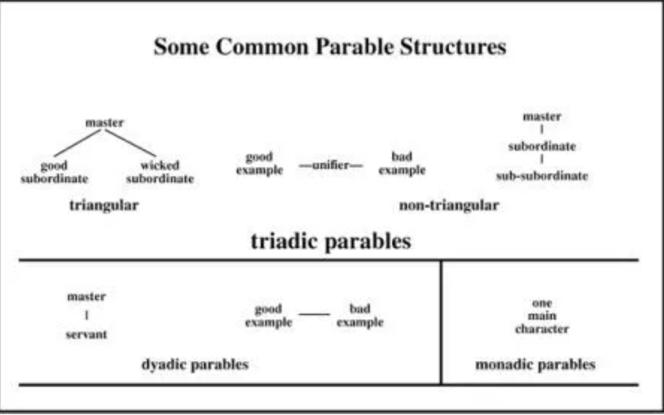

##### examples

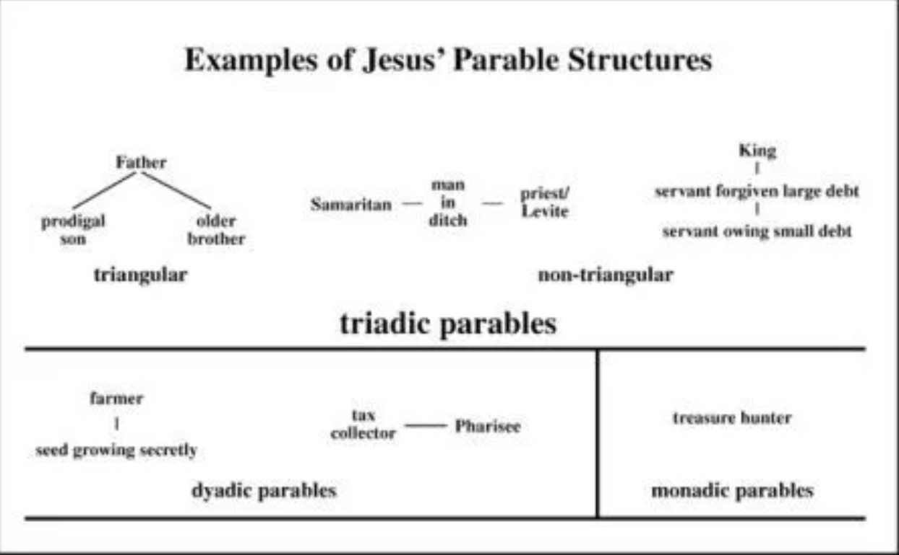

##### suggests there is one main point associated with each main character

###### so look for the characters in the parable, and search the context to see if Jesus is aiming his teaching at particular people

### note how the author has placed and shaped the parable

#### Matthew 25 a sequence of parables on being ready (wise and foolish maidens, talents, sheep and goats), following Matthew 24:3

### look for stress at the end of the parable

#### the sower 13:8-9, 23

### look for the key point(s) of story

#### in ministry of Jesus

#### for evangelists and their church(es)

### are there links with other themes in the ministry/teaching of Jesus?

## Some examples

### A three-point parable: the two sons Matthew 21:28-32

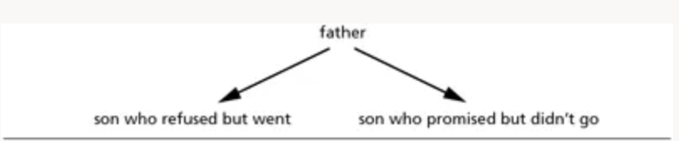

#### Jesus offers a sharp challenge—it is the last week of his life, in his final visit to Jerusalem

##### There is still the chance to change your mind: note priests who become believers in Acts 6:7

#### Can summarise with three main headings

##### (1) Like the father sending his sons to work, God commands all people to carry out his will.

##### (2) Like the son who ultimately disobeyed, some promise to do so but then renege on their promise and thus exclude themselves from God’s kingdom.

##### (3) Like the son who ultimately obeyed, some rebel but later return and obey so that they are accepted into that kingdom.

### A three-point parable: the ten bridesmaids/virgins Matthew 25:1-13



#### Two groups of bridesmaids waiting for the bridegroom to come for the wedding party—they do not know when it will happen

##### realistic picture for Jesus’ day, but not in every respect

##### these strange features point to the focus on judgement in the parable

#### Three key points

##### (1) Like the bridegroom, God/Jesus may delay his coming longer than people expect.

##### (2) Like the wise bridesmaids, his followers must be prepared for such a delay—discipleship may be harder than a beginner expects.

##### (3) Like the foolish bridesmaids, those who do not prepare well may discover a point of no return—when the end comes it will be too late to undo the damage of neglect.

### Three point parables—summary

#### God is the authority figure: he seeks the lost, welcomes sinner, forgives those who repent, calls people to obey his will, rewards and punishes people in the light of their obedience (or not), and sets a final day of judgement

#### The ‘good/wise’ person/people turn to God, repent and show love, avoid legalism, listen to Scripture, and persevere. They will receive the joy of God’s presence at the End.

#### The ‘bad/foolish’ person highlights warnings about despising God’s grace and generosity, complacency in the spiritual life, failure to keep promises to God, lack of preparation for the long journey of discipleship, being loveless or miserly (especially to those in need). They face judgement if they will not repent.

##### the purpose of the parables is to invite people to respond: they are not fixing people in categories that cannot change

### A two-point parable: the two house-builders Matthew 7:24-27



#### Two builders:

24 Everyone then who hears these words of mine and acts on them will be like a wise man who built his house on rock.

26 And everyone who hears these words of mine and does not act on them will be like a foolish man who built his house on sand.

25 The rain fell, the floods came, and the winds blew and beat on [*prosepesan*] that house, but it did not fall, because it had been founded on rock.

27 The rain fell, and the floods came, and the winds blew and beat against [*prosekopsan*ν] that house, and it fell—and great was its fall!

##### Here’s one where the parallel Jesus draws is important: 23 out of 24 Greek words are the same in vv 24-25 (the wise man) and 26-27 (the foolish man)—the exceptions are in red

##### Two key points

###### Hear and act on Jesus’ call, and you will be safe eternally—note context is 7:21-23

###### If you do not hear and act on Jesus’ call, you face disaster.

### A one-point parable

#### Hidden treasure Matthew 13:44

##### the kingdom of heaven is so valuable that it is worth sacrificing anything to get it

##### Connecting with other stories: people can be called to sacrifice their goods for God’s priorities

###### Leaving home to follow Jesus, like the disciples Matthew 4:18-22

###### Selling what you have Matthew 19:21 the rich young man who came to Jesus

## Preparation for Wednesday

Study one of these parables from Matthew with a group:

1. Matthew 18:23-35 The unmerciful servant
2. Matthew 20:1-16 The workers in the vineyard
3. Matthew 21:35-46 The sheep and the goats

### Discuss

#### What kind of parable it is (one, two, or three point)

##### And how it is organised (what are the relationships between the characters?)

##### Does the context (especially before the parable) help you understand the characters in the parable?

##### Is there exaggeration or something weird going on? Remember, this is ‘parable world’.

#### What point(s) are being made in relation to each character?

##### How would you preach on these points (in outline, not in detail)?